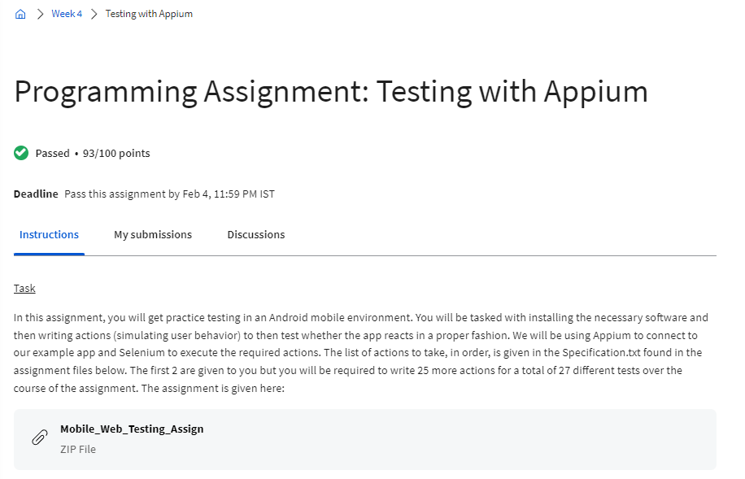

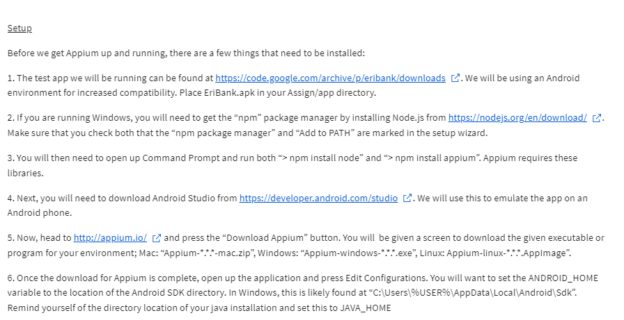

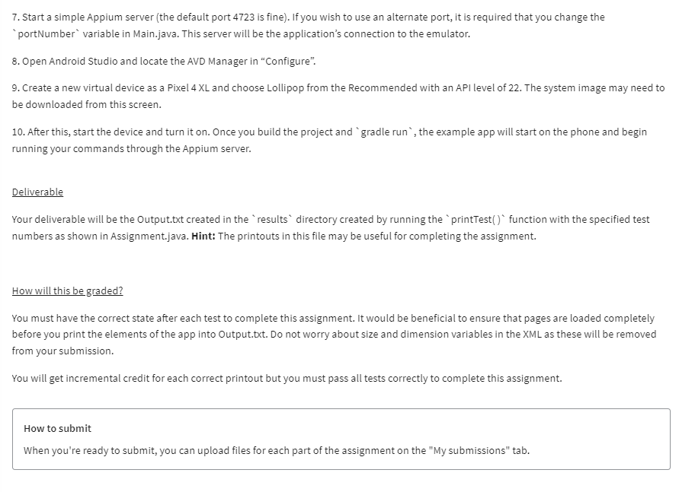

Links:

1. <https://code.google.com/archive/p/eribank/downloads>
2. <https://nodejs.org/en/download/>
3. <https://developer.android.com/studio>
4. <https://appium.io/docs/en/2.4/>